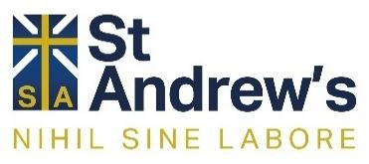

Unit | Summary | Skills | Assessment | British Values and SMSC | Career links | Cross-curricular links
Relationships and families | Students begin their GCSE course by exploring the nature of relationships and families through both a religious and non-religious lens. | Analysis  Evaluation  Research | GCSE Exam style questions | Tolerance, Respect, social | NHS  Youth work | Science  Geography
Christianity: Beliefs and teachings | Students will be studying the core beliefs and teachings in Christianity including; the nature of God, Incarnation, salvation and life after death. | Research  Decision making  Self-help | GCSE exam style questions | The rule of law, tolerance of different religions, mutual respect  Moral, social, cultural | NHS  Clergy | History  Geography
Christianity: Practices | Student will be looking in depth at worship, the sacraments, prayer, pilgrimage, festivals and mission. | Research  Debate  Public speaking | GCSE exam style questions | Individual liberty, mutual respect, tolerance of different religions, rule of law  Spiritual, moral, cultural | Travel industry | Geography
Islam: Beliefs and teachings | Students will be studying the core beliefs and teachings in Islam, with a focus on the nature of  God, and the prophets. | Language | GCSE exam style questions | Individual liberty, mutual respect, tolerance of different religions, rule of law  Spiritual, moral, cultural | Various | History
Religion, peace and conflict | Students consider the beliefs of Christians and Muslims with regards to conflict. Students will consider the concepts of justice, forgiveness and reconciliation. Students will further explore terrorism, war, pacifism and just war theory. | Compare  Contrast  Analysis | GCSE exam style questions | Tolerance for different religions and cultures. mutual respect  SMSC | NHS  Military | Science  Technology
Revision and preparation | Students will revise the topics of; Religion, Peace and Conflict, and Christianity Beliefs and Practices.  Students can look at previous units for the key words. | Research  Discussion | GCSE mock exam | British Values  SMSC | Varied | History  Geography  Science  Technology

